**THIẾT KẾ PUSH-DOWN STACK SỬ DỤNG RAM 32X8**

**\*Nguyên tắc hoạt động:**

**\*Symbolic design:**

**\*Operator table:**

**\*Control Table:**

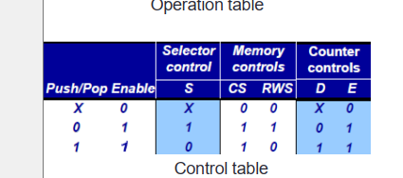

* **S = Pop’ . Enable**
* **CS = En**
* **RWS = Pop’ . Enable**
* **D = Pop.Enable**
* **E = Enable**

**\*\* Các khối logic sử dụng:**

**-RAM 32x8:**

**-Counter 5bit up/down:**

**-Mux21 5bit:**

**-Control logic:**

**+schematic:**

**+Đóng gói:**

**\*Sơ đồ kết nối:**

**\*Schematic:**

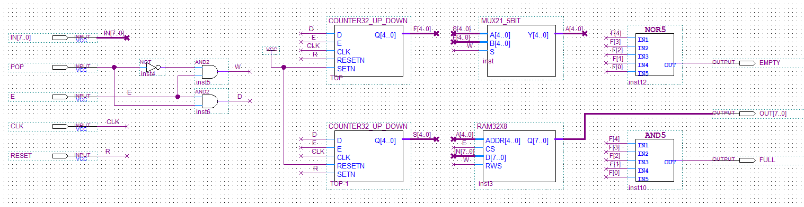

**\*Đóng gói:**

**\*Kết quả mô phỏng:**

